Landon D. Newman

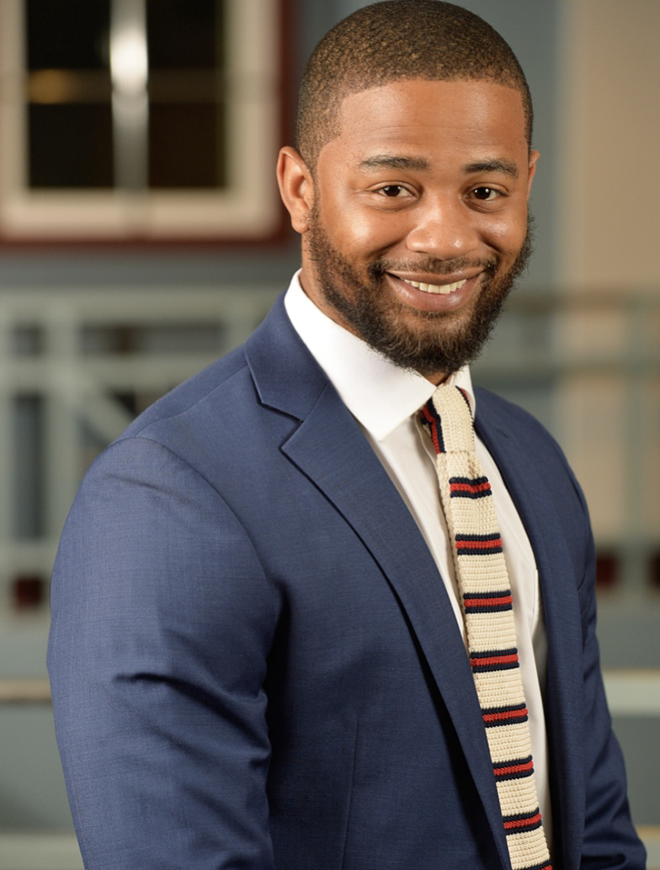
Landon D. Newman is an Assistant Vice President (AVP) Enterprise Vendor Manger (EVM), under Bank of Americas Corporate Enterprise Marketing Operations department, located in Washington D.C. He currently supports eight lines of business vendor-ships under Bank of America’s global Third-Party Vendor Management program in the Chief Administrative Office. Vendor management is the multi-stage process of initiating and developing relationships with providers of goods and services that Bank of America needs for day-to-day operations and the fulfillment of its mission.

In this capacity, Mr. Newman manages multiple fortune 500 Vendor relationships such as Facebook, Amazon, Disney, to name a few- Bank of America relies heavily on third parties to deliver our products to its customers.

Prior to joining Bank of America’s corporate team, Mr. Newman served eight years in the United States Armed Forces as a Unit Supply Specialist stateside and was also deployed in combat overseas. Mr. Newman is a decorated combat war veteran. Mr. Newman received his B.A. in Organizational Communications from Queens University of Charlotte, in North Carolina where he also created the first black student union in the university’s history and is a graduate of Waterloo East High School, Class of 2004. Mr. Newman is married to Cierra Newman of 12 years, he and his wife Cierra love to travel the world together, while establishing cultural connections. Mr. Newman is an avid volunteer in his local community and an active Prince Hall Mason, the First historical black fraternal organization.

